Crypto Watcher + Lovable UI

Technical Documentation
Crypto Price Monitoring System

Tools Used: Make.com · CoinGecko API · Google Sheets · Telegram · Slack · Lovable · Cron-job

Author: Okpara Kenneth Chinonso
Email: nonsoskyokpara@gmail.com
Date: April 2026

1. System Overview
The Crypto Watcher is an automated cryptocurrency price monitoring system built using Make.com as the automation backbone. The system fetches live crypto data from the CoinGecko public API, applies filtering logic to detect significant price movements and trending coins, delivers real-time alerts via Telegram and Slack, logs all data to Google Sheets, and displays a live dashboard via a Lovable-generated frontend UI.

The system is triggered via a webhook that can be called on a schedule by cron-job.org or manually via the Run Monitor button in the Lovable dashboard. Once triggered, the scenario branches into two independent paths — one for monitoring tracked coin prices and one for detecting globally trending coins.
Core components:
- Make.com — handles all automation, data retrieval, filtering and notifications
- CoinGecko API — provides free real-time cryptocurrency market data with no API key required
- Google Sheets — serves as the data store and live bridge between Make.com and the frontend
- Lovable — generates and hosts the responsive frontend dashboard
- cron-job.org — external free scheduler that triggers the Make.com webhook on a set interval
- Telegram Bot — receives price alert notifications
- Slack — receives trending coin notifications

2. System Architecture
The diagram below shows the complete Make.com scenario with all modules connected across both branches.
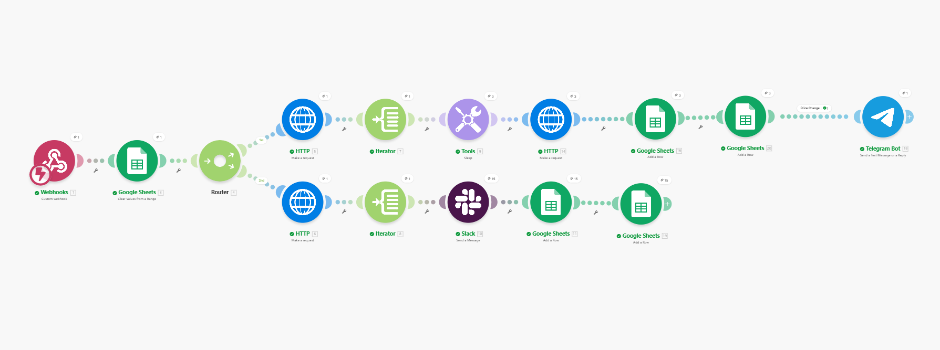
Figure 1: Full Make.com scenario — Webhook → Google Sheet → Router → Branch 1 (Price Alerts) and Branch 2 (Trending Coins)
The flow begins with a single Webhook trigger. A Google Sheets Clear Values module immediately wipes the Latest tab to prepare for fresh data. The Router then splits execution into two completely independent branches that run in parallel.

3. Make.com Scenario Setup

3.1 Webhook Trigger
The scenario is initiated by a custom webhook created in Make.com under the Webhooks module. The webhook generates a unique URL that acts as the entry point for the entire automation.
The webhook URL is registered on cron-job.org to fire automatically every 30 minutes by sending a POST request. The same webhook URL is also embedded in the Lovable dashboard's Run Monitor button for manual on-demand triggering.
To create the webhook in Make.com:
- Add a Webhooks → Custom webhook module as the first module
- Click Add to generate the unique webhook URL
- Copy the URL and paste it into cron-job.org as a new cronjob set to POST every 30 minutes

3.2 Google Sheets — Clear Values
Immediately after the webhook and before the Router, a Google Sheets → Clear Values module wipes the Latest tab clean. This ensures the Lovable UI dashboard always reflects only the most recent scenario run rather than accumulating historical rows.
Configuration:
- Spreadsheet: Crypto Watcher (your Google Sheet)
- Sheet: Latest
- Range: A2:I1000 — clears all data rows while preserving the header row in Row 1

3.3 Router
A Router module immediately after the Clear Values module splits the scenario into two independent branches. Each branch runs completely separately with its own data sources, iterators and notification channels.
- Branch 1 (labelled Price Change) — monitors three tracked coins for significant price movements. Note: I used only 3 coins (bitcoin, ethereum and Solana) to avoid pulling a lot of data and I am also in free plan.
- Branch 2 (labelled Fallback/Trending) — independently fetches and notifies about globally trending coins

4. Branch 1 — Price Monitoring

4.1 HTTP Module — Fetch Market Data
The first HTTP module on Branch 1 calls the CoinGecko /coins/markets endpoint to retrieve live market data for the three tracked coins in a single API call.

Parameter | Value
URL | https://api.coingecko.com/api/v3/coins/markets
Method | GET
vs_currency | usd
ids | bitcoin, ethereum, solana
order | market_cap_desc
price_change_percentage | 24h
Parse response | Yes

Data returned per coin:
- current_price — current price in USD
- price_change_percentage_24h — percentage change over last 24 hours
- market_cap — total market capitalisation
- total_volume — 24-hour trading volume
- last_updated — ISO timestamp of last data update
- image — URL of the coin logo

4.2 Iterator
An Iterator module loops through the array of coins returned by the HTTP module. Without the Iterator, Make.com would treat all three coins as a single bundle. The Iterator splits them so every downstream module processes each coin individually — one bundle per coin, three total runs through the rest of Branch 1.
Configuration: Array field is set to Data[] from the HTTP module output.

4.3 Sleep Module
A Tools → Sleep module is placed between the Iterator and the second HTTP module, set to 2000 milliseconds (2 seconds). This delay prevents hitting CoinGecko's free tier rate limit when making individual coin detail calls in rapid succession for each coin in the loop.

4.4 HTTP Module — Fetch Coin Metadata
A second HTTP module calls the CoinGecko /coins/{id} endpoint for each individual coin to retrieve metadata not available from the markets endpoint. The coin ID is dynamically populated from the Iterator using the {{id}} variable.
GET https://api.coingecko.com/api/v3/coins/{{id}}
Additional data returned:
- links.homepage[0] — official website URL
- description.en — coin description text
- Additional metadata fields

4.5 Google Sheets — Log All Coins
Before applying any alert filter, two Google Sheets modules log every coin's data regardless of whether its price change meets the threshold. This is a critical design decision — the dashboard must always display all tracked coins, not just the ones that triggered alerts.
Two modules run sequentially for each coin:
- First module writes to the Latest tab — this is what the Lovable dashboard reads
- Second module writes to the History tab — this maintains a permanent audit log
Alert Type is set to the static text 'Price Alert' for all rows on this branch.

4.6 Filter — Price Change Threshold
A Filter module checks whether the coin's 24-hour price change percentage exceeds the alert threshold. Only coins that pass this filter continue to the Telegram notification. Coins that do not pass are silently stopped — they have already been logged to Google Sheets in the previous step.
Filter conditions:
price_change_percentage_24h Greater than 5
OR
price_change_percentage_24h Less than -5
This catches both upward spikes and significant drops. The threshold can be adjusted by editing the filter condition values.

4.7 Telegram Bot — Price Alert Notification
For coins that pass the filter, a Telegram Bot module sends an alert message to a configured chat ID. The Telegram bot is created via BotFather and connected to Make.com via the bot token.
Message format used:
🚨 Price Alert!

Coin: {{7.name}}
Symbol: {{7.symbol}}
Price: ${{7.current_price}}
24h Change: {{7.price_change_percentage_24h}}%
Market Cap: ${{7.market_cap}}
Volume: ${{7.total_volume}}
Last Updated: {{7.last_updated}}
Logo: {{7.image}}
Official website: {{14.data.links.homepage[]}}
Description: {{14.data.description.en}}

5. Branch 2 — Trending Coins

5.1 HTTP Module — Fetch Trending Coins
The second branch operates completely independently from Branch 1. It fetches the current global trending coins from CoinGecko's dedicated trending endpoint. No parameters are required — the endpoint always returns the top 7 coins trending on CoinGecko based on search volume in the last 24 hours.
GET https://api.coingecko.com/api/v3/search/trending
This branch is not limited to the three coins tracked in Branch 1. It monitors the entire CoinGecko platform for any coin gaining traction globally, satisfying the requirement to notify about newly trending or listed coins.

5.2 Iterator
An Iterator loops through the coins[] array returned by the trending endpoint. Unlike Branch 1 which uses Data[], this Iterator points to the coins[] key specifically since the trending endpoint nests its array inside a coins property.
This produces up to 7 individual bundles — one per trending coin — which then each proceed independently to the Slack notification and Google Sheets logging.

5.3 Slack — Trending Coin Notification
A Slack module sends a formatted message to a configured public Slack channel for each trending coin. The connection uses OAuth authentication through Make.com's Slack integration.
Message format used:

🔥 Trending Coin

Coin Name: {{8.item.name}}

Symbol: {{8.item.symbol}}

Price: ${{8.item.data.price}}

Volume: {{8.item.data.total_volume}}

Market Cap: {{8.item.data.market_cap}}

Market Cap Rank: {{8.item.market_cap_rank}}

Image: {{8.item.small}}

5.4 Google Sheets — Log Trending Coins
Two Google Sheets modules on Branch 2 log each trending coin to both tabs identically to Branch 1. The Alert Type column is set to the static text 'Trending Alert' so the Lovable dashboard can filter and display trending coins separately from price alert coins.

6. Google Sheets Structure
A single Google Sheet named Crypto Watcher contains two tabs that serve different purposes for the system.

6.1 Latest Tab
The Latest tab is cleared at the start of every scenario run by the Clear Values module and then rewritten with fresh data from both branches. The Lovable dashboard reads exclusively from this tab via a published CSV URL. It always contains only the data from the most recent run — never historical rows.

6.2 History Tab
The History tab is never cleared — it is only ever appended to. Every scenario run adds new rows for all coins processed on both branches. This provides a complete audit log of all price data and alerts over time, useful for trend analysis and documentation.

6.3 Column Structure
Both tabs share the same column headers:

Column | Description | Example
Coin Name | Full name of the coin | Bitcoin
Symbol | Ticker symbol | BTC
Price (USD) | Current price in US dollars | $66,402.00
24h Change % | Price change over last 24 hours | -3.18%
Market Cap | Total market capitalisation | $1.33T
Volume | 24-hour trading volume | $44.50B
Last Updated | Timestamp of last data update | 2026-04-02T11:35:16Z
Alert Type | Type of alert that triggered this row | Price Alert / Trending Alert

6.4 Publishing the CSV URL for Lovable
To connect the Google Sheet to the Lovable dashboard:
- Open the Google Sheet and click File → Share → Publish to web
- In the first dropdown select the Latest tab specifically (not Entire Document)
- In the second dropdown select Comma-separated values (.csv)
- Click Publish and copy the generated URL
- Paste this URL into the Lovable project as the data source
The published URL contains a gid parameter that uniquely identifies the Latest tab, ensuring Lovable always reads only that tab and never the History tab.

7. Lovable Frontend Dashboard

7.1 Overview
A responsive frontend dashboard was built using Lovable at lovable.dev and deployed as a public web application. The dashboard reads data from the Google Sheets Latest tab via the published CSV URL and automatically refreshes every 60 seconds to display current data.
Live URL: coin-hearth-monitor.lovable.app
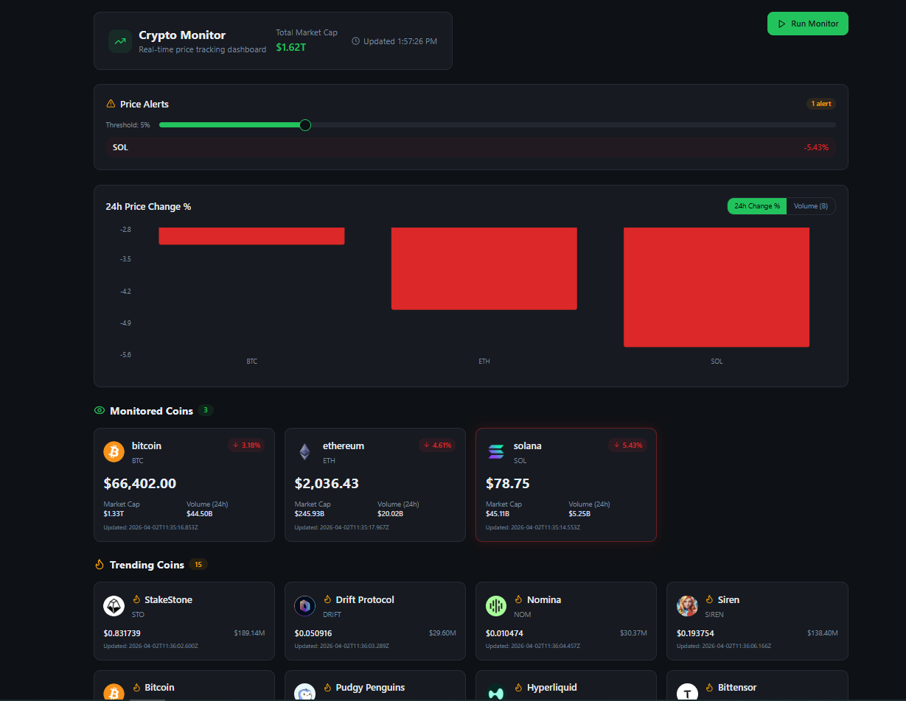
Figure 2: Lovable dashboard showing Monitored Coins, Trending Coins, Price Alerts panel and 24h Change chart

7.2 Dashboard Features
- Header — displays total market cap of monitored coins and last updated timestamp
- Price Alerts panel — highlights coins exceeding the threshold with a live count and adjustable slider from 1% to 20%. Solana showing -5.43% is highlighted as it exceeds the 5% threshold
- 24h Price Change chart — bar chart with green bars for gains and red bars for losses, toggleable between 24h Change % and Volume (B) views
- Monitored Coins section — displays cards for all rows where Alert Type = Price Alert, showing price, 24h change %, market cap, volume and last updated time. Solana's card is highlighted in red as it triggered an alert
- Trending Coins section — displays cards for all rows where Alert Type = Trending Alert, showing coin name, symbol, market cap rank and last updated time
- Run Monitor button — top right button that sends a POST request to the Make.com webhook URL to trigger an immediate scenario run
- Auto refresh — fetches fresh CSV data from Google Sheets every 60 seconds automatically
- Fully responsive — works on both mobile and desktop screens

7.3 How the Dashboard Connects to Make.com
The connection between Lovable and Make.com works through two mechanisms:
Google Sheets CSV (data display): Make.com writes coin data to Google Sheets after every run. Lovable reads the published CSV URL every 60 seconds and renders the data on screen. This means the dashboard always reflects the output of the last Make.com scenario run.
Webhook button (manual trigger): The Run Monitor button in the dashboard sends a POST request directly to the Make.com webhook URL. This allows triggering the full scenario on demand without waiting for the cron-job.org schedule.

7.4 Deployment Instructions
To deploy or redeploy the Lovable dashboard:
- Go to lovable.dev and open the project
- Make any edits via the chat interface or code editor
- Click Publish in the top right corner
- Copy the generated public URL to share or include in documentation
- The same URL updates automatically on every subsequent publish
To transfer the project to another Lovable account, use the GitHub export feature: click the GitHub icon, push to a repository, then import from GitHub on the new account.

8. How to Maintain the System

8.1 Changing Tracked Coins
- Open Make.com and edit the first HTTP module on Branch 1
- Update the ids query parameter with new CoinGecko coin IDs
- Use lowercase IDs as they appear on CoinGecko (e.g. bitcoin, ethereum, solana)
- Keep the total to 5 coins or fewer on the free CoinGecko tier to avoid rate limit errors
- Save and run once to confirm the new coins appear in Google Sheets and on the dashboard

8.2 Changing the Alert Threshold
- Open Make.com and click the Filter module on Branch 1
- Update the condition values from 5 and -5 to your desired percentage
- Save the filter — the change takes effect on the next scenario run
- The threshold slider on the Lovable dashboard is a frontend-only UI control — it does not change the Make.com filter

8.3 Adding a New Notification Channel
- Add a new module after the Filter on Branch 1 (Email, SMS via Twilio, etc)
- Connect your account credentials through Make.com's connection manager
- Map the same coin data fields to the message template using the variable picker
- Save and trigger the webhook once to test the new channel

8.4 Extending to More Coins
- Add more coin IDs to the ids parameter in HTTP module on Branch 1
- Increase the Sleep module delay to 300secs or more if rate limit errors occur
- Consider upgrading to a paid CoinGecko API key for higher rate limits if tracking more than 10 coins

9. Testing Checklist
Test | Expected Result | Status
Webhook trigger fires via cron-job.org | Make.com scenario starts automatically | ✓ Passed
Webhook trigger fires via Lovable button | Make.com scenario starts on demand | ✓ Passed
Google Sheets Latest tab cleared on run | Only current run data in Latest tab | ✓ Passed
CoinGecko /coins/markets returns data | 3 coins with full market data | ✓ Passed
Iterator loops through 3 coins | Each coin processed individually | ✓ Passed
Sleep prevents rate limit errors | All 3 coin detail calls succeed | ✓ Passed
Google Sheets logs all coins before filter | Rows added regardless of threshold | ✓ Passed
Filter passes threshold coins only | Only ±5% coins proceed to Telegram | ✓ Passed
Telegram alert received | Message with full coin data delivered | ✓ Passed
Trending endpoint returns coins | Trending coins fetched from CoinGecko Trending API | ✓ Passed
Slack trending alert received | One message per trending coin | ✓ Passed
History tab accumulates all runs | Rows appended never deleted | ✓ Passed
Lovable dashboard reads Latest tab | Dashboard shows current run data | ✓ Passed
Dashboard auto-refreshes every 60s | New data appears without page reload | ✓ Passed
Price alert highlighted on dashboard | Solana card highlighted at -5.43% | ✓ Passed

10. Known Limitations
- CoinGecko free tier rate limit: The public API allows approximately 10-30 calls per minute. The Sleep module mitigates this but tracking more than 5 coins simultaneously may still cause occasional rate limit errors. A paid API key resolves this.
- Make.com free plan operations: The free plan provides 1,000 operations per month. Running every 30 minutes uses approximately 720 operations per month for 3 tracked coins. Increasing coin count or run frequency may exceed this limit.
- Google Sheets CSV cache delay: The published CSV URL has a cache delay of up to 5 minutes. This means the Lovable dashboard may display data that is slightly behind the most recent Make.com run.
- Threshold slider is frontend only: The alert threshold slider on the Lovable dashboard controls only the visual highlight on the dashboard. It does not update the Make.com filter condition. To change the actual alert threshold, the filter in Make.com must be edited directly.

11. Future Improvements
- Add SMS notifications via Twilio for high-urgency alerts above a secondary threshold such as ±10%
- Integrate a paid CoinGecko API key to increase rate limits and track more coins without sleep delays
- Add historical price sparkline charts using the CoinGecko sparkline_in_7d data field
- Replace Google Sheets with a real-time database such as Supabase or Firebase for instant dashboard updates without the 5-minute CSV cache delay
- Add user authentication to the Lovable dashboard to support personalised coin watchlists per user
- Implement a second Make.com scenario that runs daily to generate a summary digest email with market trends

End of Document

